**Experiment 8**

*Aim:* Create React Sidebar Navigation Menu for a webpage. Implement the concept of React Hooks for backward compatibility and faster user experience.

# In components folder, make *Navbar.js,* and design the Navbar

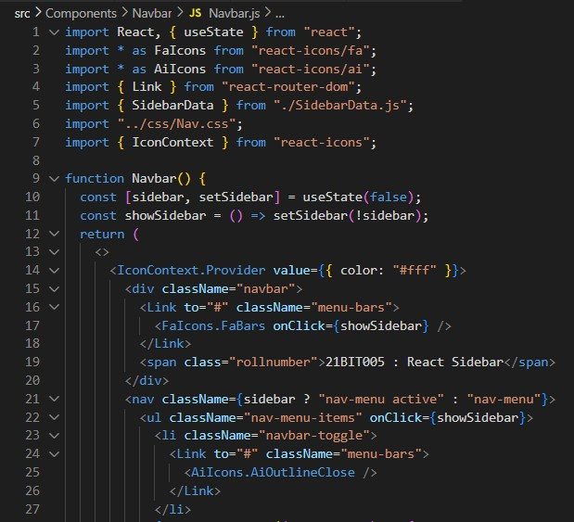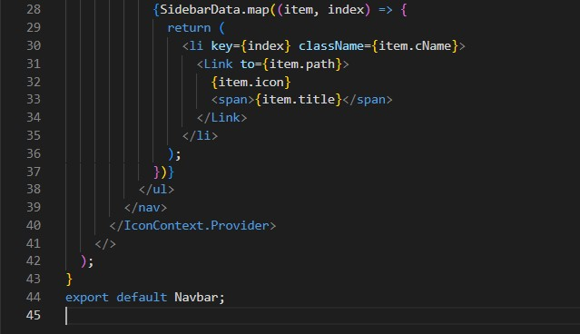

# Give CSS to Navbar

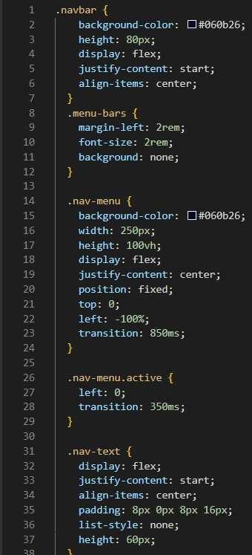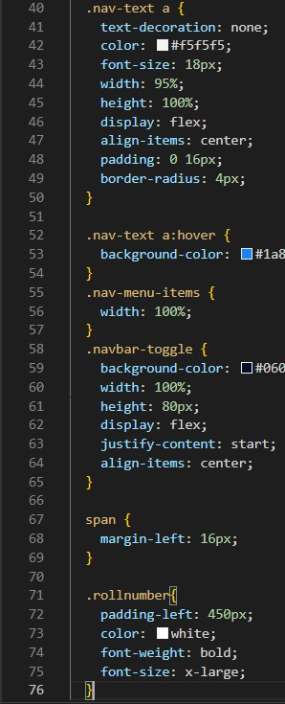

# Make a *Sidebar.js* in components folder, to design the sidebar

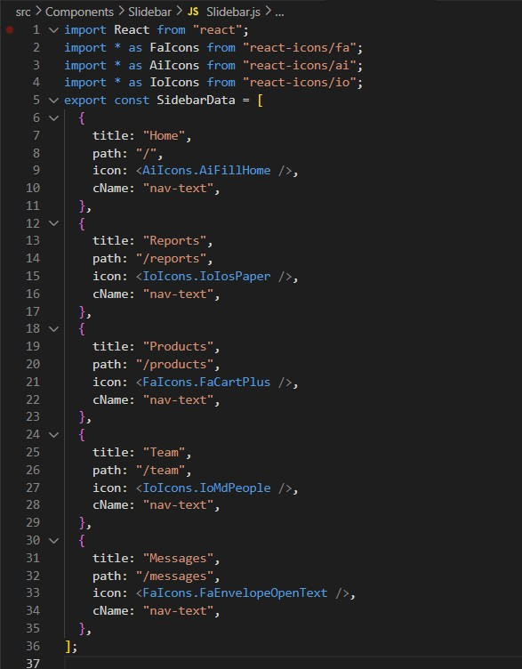

# Make a pages folder, and add the pages of the sidebar

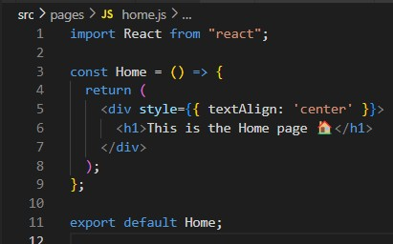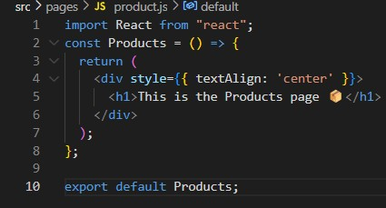

# Update the *App.js* file

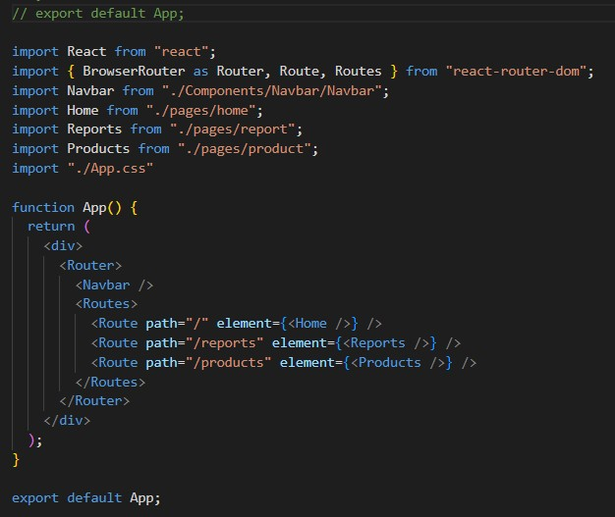

# **Output**

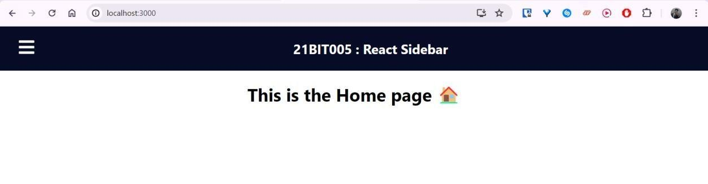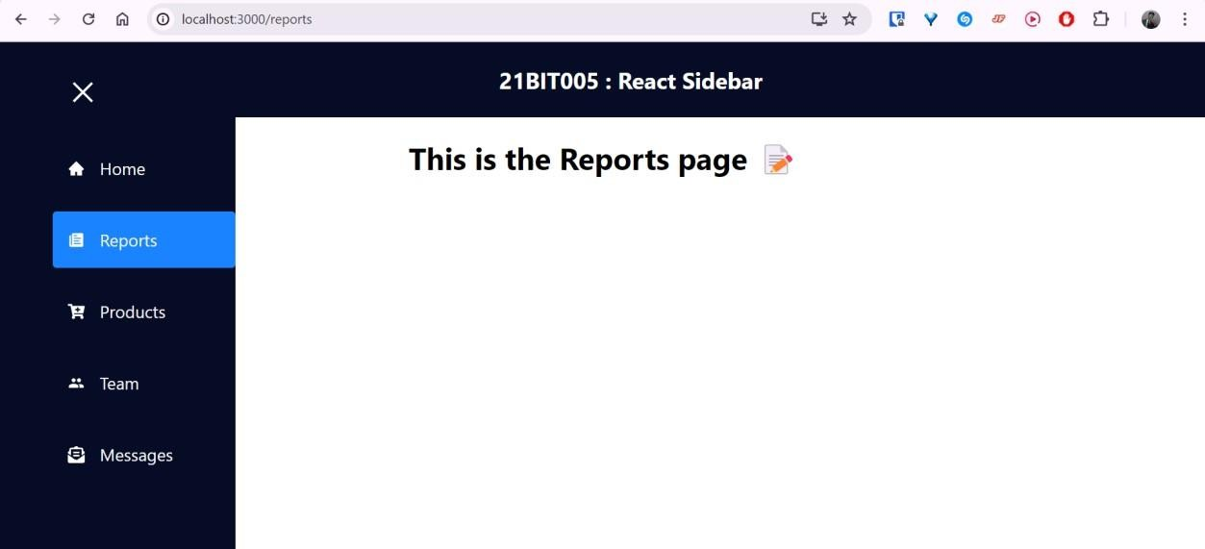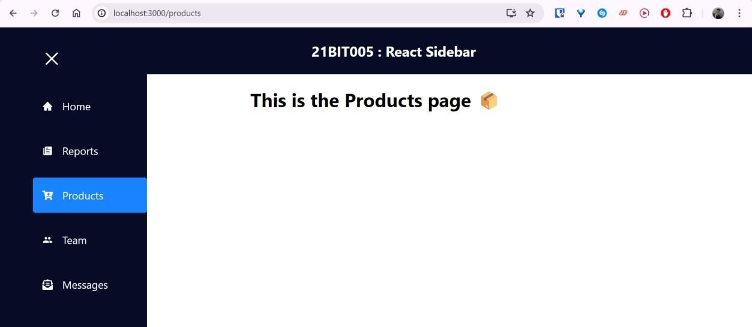

**Discussions:**

This experiment demonstrated the creation of a React sidebar navigation menu, enhancing webpage accessibility. Utilizing React Hooks ensures faster user interaction and maintains compatibility across different React versions.